**CASE STUDY: REDUCING PURCHASE ORDER CYCLE TIME, PART 1**

**Define**

In the 16 months prior to the start of this project, the Strategic Sourcing department generated approximately $10 million in savings, an amount verified by independent associates in the [Finance department](https://www.isixsigma.com/operations/finance/). While Strategic Sourcing associates at the company are responsible for the large impact to the company’s bottom line, they are also burdened with the tactical work associated with issuing a purchase order to the supplier. The time spent on this tactical work represents a loss in the department’s ability to affect the bottom line through negotiations and supplier relationship management.

**Project Charter**

**Project name**: Requisition to [purchase order process](https://www.isixsigma.com/implementation/case-studies/case-study-improving-purchase-order-process/)

**Problem statement**: 85 percent of purchase orders (POs) require manual intervention by buyers, resulting in an efficacy ratio of 44 POs/month/buyer. Company does not have a consistent process for the creation of POs in the system once a requisition is approved.

*Benchmark efficacy ratios:*

* Median: 50 POs monthly per buyer\*
* Laggard: 21 POs monthly per buyer\*

\* According to the American Productivity & Quality Center (APQC).

**Business case**: Global procurement has reported cost savings (SAR) in the amount of $9.6 million/quarter for the past 16 months. If the department can increase the productivity per buyer by 6 POs/month, this would result in 9,485 hours or 4.5 full-time employees’ (FTE) ability to instead focus on strategic value to the company. Global procurement could increase SAR by $2 million/year.

**In scope**: Requisitions that are manually sourced to a PO by a buyer. The process begins when a requisition is submitted in the system of record and ends when a PO is dispatched to a supplier.

**Out of scope**: Current catalog auto-sourced (purchase orders generated directly from an online catalog that do not require a sourcing intervention) and interface (orders that come directly into the system from a vendor site and do not require the involvement of a sourcing associate) POs. International POs or POs not sourced through procurement.

**Goal statement**: Within three months, create a consistent, documented repeatable process for creation of POs to boost the efficacy ratio of 44 POs/month/buyer to 50 POs/month/buyer.

**[Handpicked Content:   Six Sigma Proves Its Value in Funds Management](https://www.isixsigma.com/operations/finance/six-sigma-proves-its-value-mutual-funds-management/" \t "_self)**

**Cycle Time**

The [cycle time](https://www.isixsigma.com/dictionary/cycle-time/) for the purchase orders to be issued delayed the business units’ ability to receive the product and/or service associated with such savings (Figure 1). Additionally, the cycle time was interfering with the Sourcing associates’ ability to contribute toward the savings – avoidance or recovery – objectives (SAR). In addition to the dollar impact to the tactical work, multiple FTEs were needed to issue POs, creating inconsistency in timing as well as resource issues. The savings  was estimated at approximately $2 million in addition to a reduction in the number of FTEs required to process the POs.

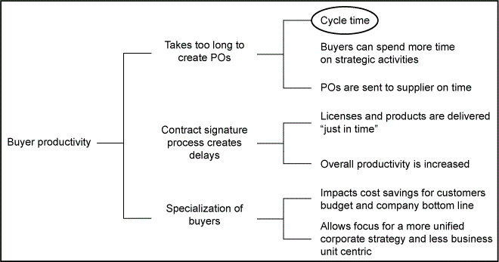

Figure 1: CTQ Drill-Down Tree

**SIPOC Analysis**

The [SIPOC (suppliers, inputs, process, outputs, customers) analysis](https://www.isixsigma.com/tools-templates/sipoc-copis/) begins with an email that is distributed to all sourcing associates that details a list of the requisitions with approval that need to be sourced to a PO. Since the categories for each sourcing associate are blurred, it’s a challenge for each associate to know who to send them to – creating distribution issues and adding to the cycle time.

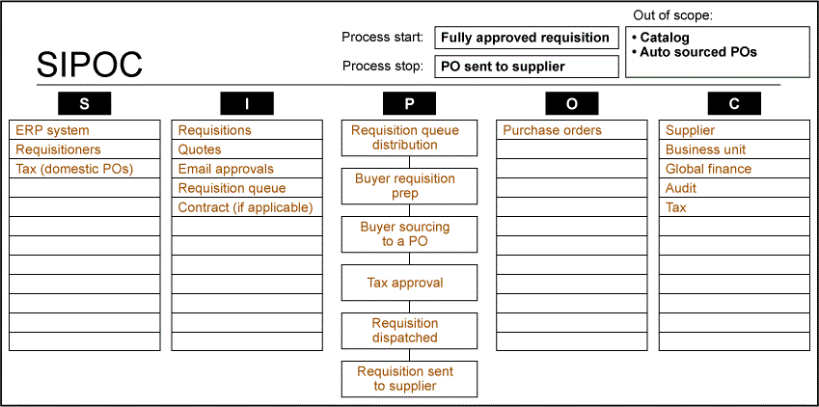

Figure 2: SIPOC Analysis

[**Voice of the Customer (VOC)**](https://www.isixsigma.com/methodology/voc-customer-focus/)

We issued a one-question survey to about 170 employees – those who issue the most requisitions throughout the company.

*Based upon your experience, how long does it take procurement to process a fully approved requisition into a purchase order?*

* 41% = less than a business week
* 31% = 2 weeks
* 24% = 1 month
* 4% = longer than a month

**Voice of the Business (VOB)**

A similar question was asked to assess the [VOB](https://www.isixsigma.com/implementation/change-management-implementation/voice-business-customer-process-and-employee/).

What is your desired timeframe for how long it should take procurement to issue a fully approved requisition into a PO?

* 72% = less than a week/5 business days

**Process Map**

Looking at the as-is [process map](https://www.isixsigma.com/tools-templates/process-mapping/building-valuable-process-maps-takes-skill-and-time/) (Figure 3), there are a striking number of steps and failure points in the process. It’s amazing that purchase orders are dispatched with any frequency! There are more than 40 steps in the current process, which has a direct result on cycle time.

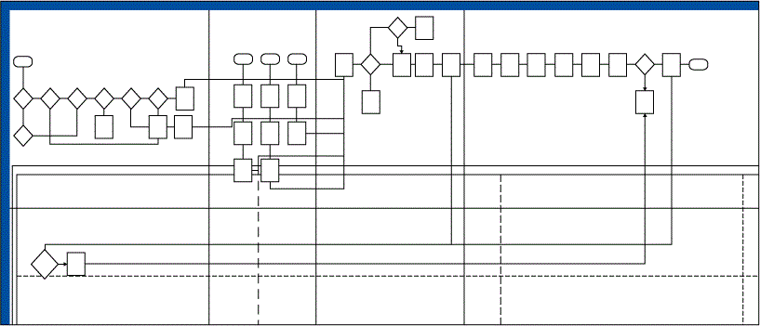

Figure 3: As-Is Process Map

**Communication Plan**

The communication plan shown in the table below was developed and shared with the project’s stakeholders.

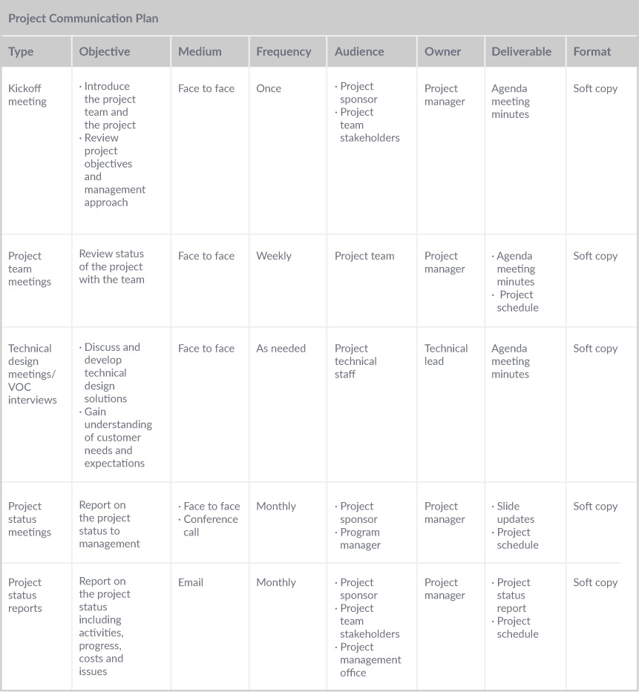

Project Communication Plan

**Measure**

**Updated**[**Project Charter**](https://www.isixsigma.com/tools-templates/project-charter/six-sigma-project-charter-vital-control-document/)

Changes to the charter were made after discussions on the potential impact of the project. It was determined that the project should result in an increase in productivity per buyer by at least 6 POs per month. The process would likely require fewer procurement representatives to process all the POs and could result in an increase in auto-sourced POs – or even move these to the Procurement to Pay (P2P) team. This, in turn, would free up resources from procurement to focus on strategic activities. This increase in productivity by the same 13.6 percent (the increase from 44 POs/buyer/month to 50 POs/buyer/month) should increase the SAR by an additional $5.5 million.

**[Handpicked Content:   LSS Streamlines OR at Thibodaux Regional Medical Center](https://www.isixsigma.com/implementation/case-studies/lss-streamlines-or-thibodaux-regional-medical-center/" \t "_self)**

**Updated business case**: Global Procurement reported SAR in the amount of $9.6 million/quarter for the past 16 months. If the team can increase the productivity per buyer by 6 POs, this would result in a 13.6 percent increase in POs/buyer and allow the P2P team to source all POs under $50,000. This in turn would allow Sourcing to focus on strategic activities, which should increase productivity by the same 13.6 percent, resulting in an additional cost savings of $5.5 million.

**In scope**: PeopleSoft (supply chain management software) requisitions that are manually sourced to a PO by a buyer. The process begins when a requisition is submitted in PeopleSoft and ends when a PO is dispatched to a supplier.

**Out of scope**: Current catalog auto-sourced and interface POs.

**Qualitative Analysis**

In order to make the process efficient enough to either auto-source POs or transfer responsibility to the P2P team, it was necessary to review the as-is process map and determine which steps were non-value added. These steps couldn’t necessarily be immediately eliminated – it’s likely that a complete reconfiguration of the process would be needed. However, identifying the non-value added steps showed the team the complicated workflows that have high numbers of potential failure points and add additional stress to the outcome of the process. (See Figure 4.) The red process steps represented non-value added steps that do not contribute toward the completion of the activities. The yellow process steps represented value-enabled steps (steps that were added to satisfy stakeholder requirements). The green steps represented value-added steps (steps that contributed to the completion of the process).

The review revealed two key findings:

1. 23 of the 43 steps were determined as non-value added steps.
2. Fully one-half of the steps determined how to distribute requisitions to the correct buyer.

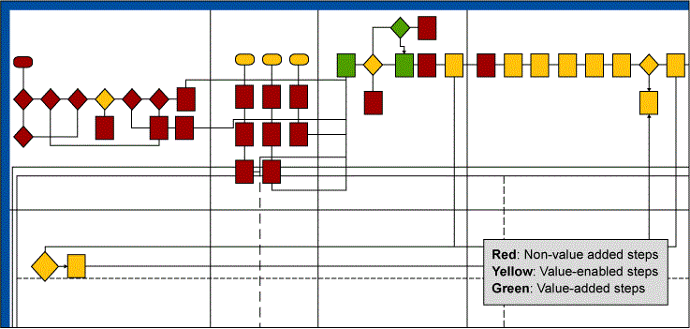

Figure 4: Revised Process Map

**Measurement Plan**

**[Handpicked Content:   Reducing Delayed Starts in Specials Lab with Six Sigma](https://www.isixsigma.com/new-to-six-sigma/dmaic/reducing-delayed-starts-specials-lab-six-sigma/" \t "_self)**

This measurement plan was originally sent out to determine the length of time taken for each PO. As the project proceeded in the Measure phase, the focus shifted from the time to complete the PO to the number of days it took before the PO was dispatched to the supplier. The measurement plan included the total number of minutes spent processing purchase orders. After the VOC survey it became clear that our internal clients were concerned with the length of time expressed as number of days as opposed to the number of minutes it took for an associate to produce a purchase order. It was also better data because we could precisely calculate the time the requisition was approved from the time the PO was dispatched thanks to the system’s time stamps. In addition, when looking at the problems in the Define and Measure phases, it became clear that the actual time spent producing the PO was irrelevant because even if we were able to speed that up, it would still bottleneck at the distribution phase (from how the requisitions were assigned to each associate for processing into a PO). We couldn’t meet our clients’ requirements until the distribution was fixed. Once the baseline data was collected, it became apparent the 40-step process was breaking down in the distribution of the requisitions to the buyers. While the mean number of days for 2015 and 2016 was relatively low (3 and 2, respectively), the standard deviation was another story. The standard deviation for 2015 was at 12 and 4.5 for the first part of 2016. This meant that the USL – upper specification limit, which was defined in this project as the number of days acceptable to issue a PO by our internal customers – was exceeded a whopping 47 percent (2015) and 33 percent (2016). Said another way, almost half of the POs that were being issued went beyond the five-day acceptable service level set by the internal customers (Figure 5).

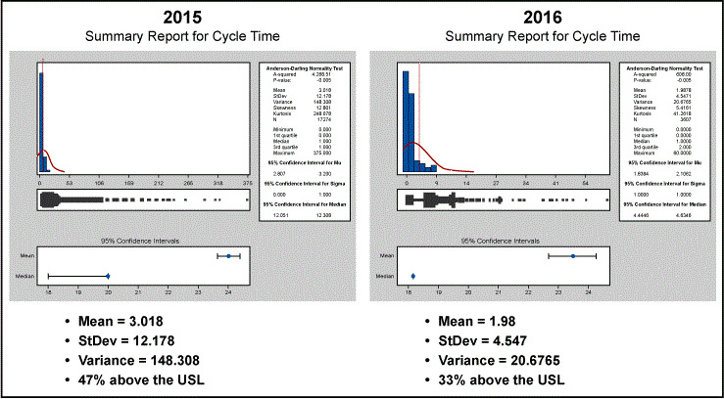

Figure 5: Baseline Performance for 16 Months Prior to the Start of the Project

Once the numbers provided insight to the significance of the problem, a [fishbone diagram](https://www.isixsigma.com/resource-pages/the-fundamentals-of-cause-and-effect-aka-fishbone-diagrams/) was created (Figure6) after a brainstorming session to highlight potential areas to test. The circled items represent areas the team wanted to test to determine how likely each issue was to affect the overall cycle time of the PO process.

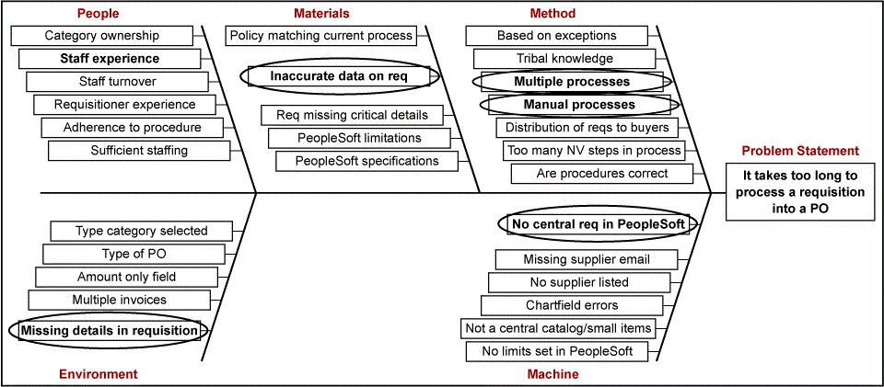

Figure 6: Fishbone Diagram

**CASE STUDY: REDUCING PURCHASE ORDER CYCLE TIME, PART 2**

**Analyze**

The baseline summary shown in Figure 1 details the cycle time from the last measure ([in the Measure phase](https://www.isixsigma.com/implementation/case-studies/case-study-reducing-purchase-order-cycle-time-part-1/)) to the tollgate presentation for the Analyze phase. The average queue time shows a mean of 2.7 days but a large standard deviation of 9. This means that 44 percent of the purchase orders that were being sourced were outside of the upper specification limit (USL) of 5 days, as determined by the voice of the customer surveys sent out in the Define phase.

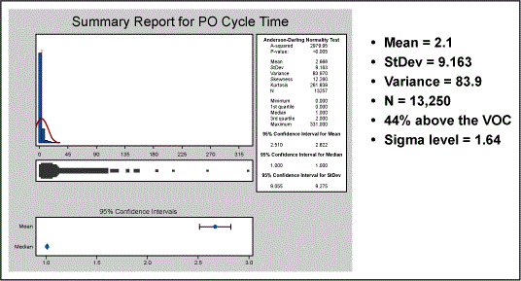

Figure 1: Baseline Performance – One Year

**Root Cause Analysis**

It was then time to start a root cause analysis. Table 1 shows the potential [root causes](https://www.isixsigma.com/tools-templates/cause-effect/final-solution-root-cause-analysis-template/) on the left and which statistical testing method was used on the right.

|  |  |
| --- | --- |
| Table 1: Hypothesis Test Plan | |
| Potential Root Cause (from Measure) | **Hypothesis Test** |
| Business unit | Equal variance, analysis of variance (ANOVA) |
| Dollar amount | Multiple regression, fitted |
| Category | One-way ANOVA |
| Requisition distribution | Multiple regression, fitted line |
| Contract signature | T-test, ANOVA |

Table 2 explores the next step. Tests were completed and the results showed some areas with existing correlation that needed focus and some areas with minor-to-no correlation that could be dismissed.

|  |  |
| --- | --- |
| Table 2: Hypothesis Testing Results | |
| Hypothesis Tested | **Result** |
| Business unit/segment grouping | Correlation exists = 8.4% of the issue/correlation exists = 5.21% of the time |
| Dollar amount | No correlation exists |
| Category | Correlation exists = 9% of the issue |
| Requisition distribution | Correlation exists = 96% of the issue |
| Contract signature | Correlation exists = 1.6% of the issue |
| Month of PO | No correlation exists |
| Value bucket | Minor correlation |
| Amount only | Minor correlation |
| Base currency | Correlation exists = 5.4% of the issue |
| PO dollar value | No correlation exists |

Figures 2 through 6 illustrate some of the various hypotheses, tests and results, some of which showed some correlation between the subject and the impact on cycle time.

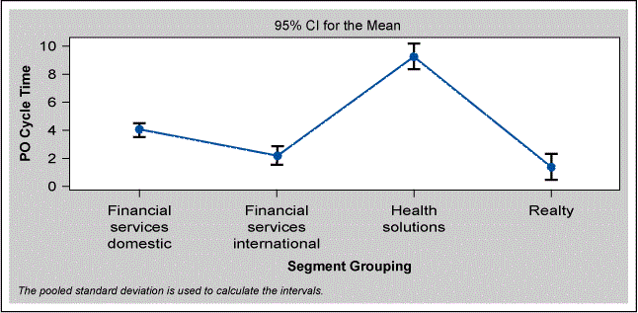

Figure 2: Interval Plot of PO Cycle Time vs Segment Grouping

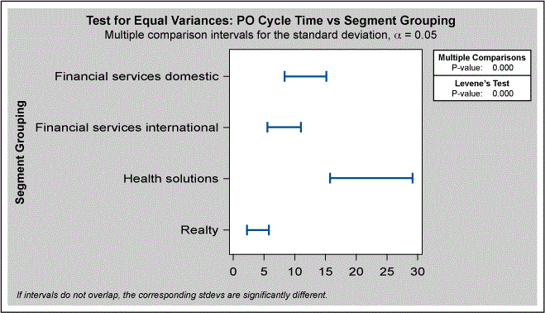

Figure 3: Test for Equal Variances – PO Cycle Time Vs Segment Grouping

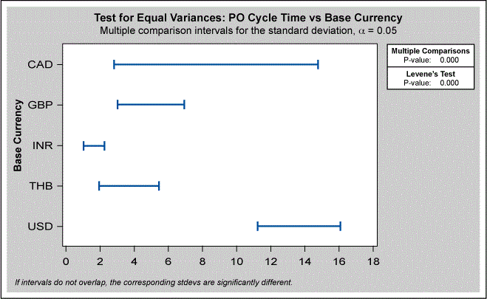

Figure 4: Test for Equal Variances – PO Cycle Time Vs Base Currency

**Queue Time**

**[Handpicked Content:   Case Study: DMAIC Project Improves Hospital's On-time Completion of Administrative Tasks](https://www.isixsigma.com/implementation/case-studies/case-study-dmaic-project-improves-hospitals-on-time-completion-of-administrative-tasks/" \t "_self)**

None of the above analyses, however, illustrated the impact that [queue time](https://www.isixsigma.com/industries/retail/queuing-theory-and-practice-source-competitive-advantage/) – the amount of time a requisition sits in the queue before it is manually distributed to an analyst for sourcing to a PO – had on cycle time.

In Figure 5, the fitted line graph displays the close connection between cycle time and when and to whom the purchase orders are distributed with an R-square (the statistical measure of how close the data is to the fitted regression line) of 96 percent.

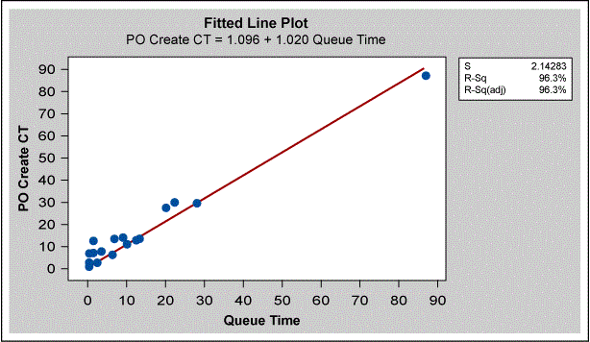

Figure 5: Queue Time and Cycle Time Relationship

Figure 6 confirms that how requisitions are distributed dramatically impacts the cycle time. The analysis shows a mean queue time of 7 days, which is already above the USL for the entire cycle time.

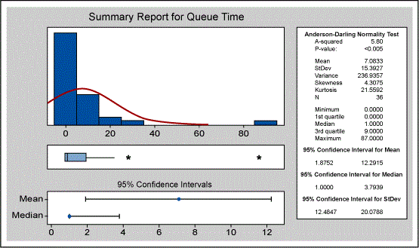

Figure 6: Summary Report for Queue Time

The as-is process for [requisition](https://www.isixsigma.com/implementation/communication/reserve-unit-improves-requisition-process/) distribution requires an automated email to be distributed to one analyst (each team sourcing team member takes a turn weekly) to, in turn, distribute to another buyer. There are numerous issues with this distribution method.

* What if the designated buyer is out of the office during their specified week?
* What if the person receiving the requisition to source is out of the office?
* What if other responsibilities cause a delay in a day or two when they should be passing out requisitions?

There are many more possibilities of errors that can occur at this failure point.

Once requisitions are directed to the correct person, they are sourced extremely quickly. (See Figure 7.) With a mean of 2.1 and a standard deviation of 2.7 days, it’s clear that automation around the distribution of purchase orders will help to clear up the cycle time issues. Here, the mean, standard deviation and *p*-value relate to the amount of time the requisition sits once in the correct queue before being sourced to a purchase order.

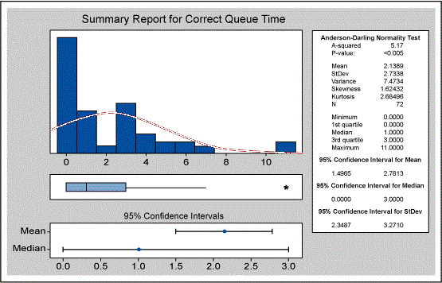

Figure 7: Summary Report for Correct Queue Time

Figures 8 and 9 look at the relationship among categories (e.g., software and hardware) and the cycle time as well as value buckets (e.g., requisitions in the categories of less than $50K or less than $100K). The hypothesis was that the higher the dollar requisition, the more attention it received and the less likely it was to contribute to the delay in cycle time. The tests also shed some light on how requisitions should be segmented toward the buyers.

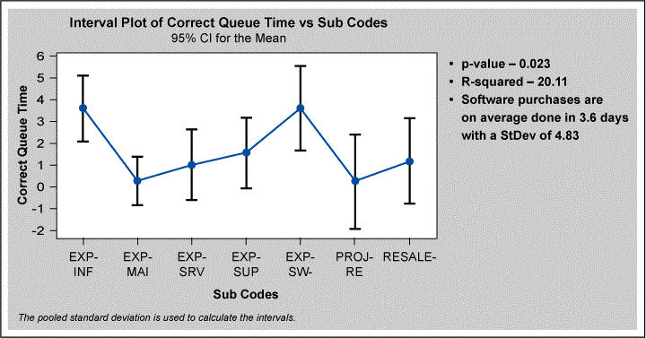

Figure 8: Interval Plot of Correct Queue Time Vs Subcodes

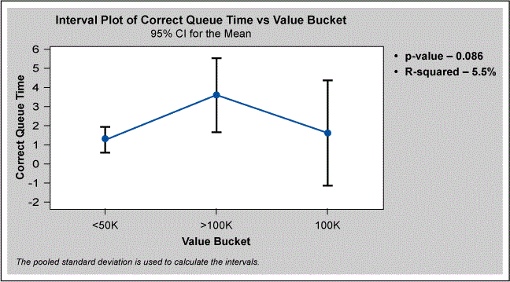

Figure 9: Interval Plot of Correct Queue Time Vs Value Bucket

A vital few [validated root causes](https://www.isixsigma.com/tools-templates/5-whys/case-study-using-the-5-whys-to-validate-assumption/) were discovered:

* Requisition distribution
  + *p*-value = 0.00
  + R-squared (adjusted)[[1]](#footnote-1) = 96 percent
* Business unit/segment grouping
  + *p*-value = 0.00
  + R-squared (adjusted) = 8.4 percent
* Base currency
  + *p-value = 0.00*
  + *R-squared (adjusted) = 5.4 percent*

**[Handpicked Content:   Calculating ROI to Realize Project Value](https://www.isixsigma.com/implementation/financial-analysis/calculating-roi-realize-project-value/" \t "_self)**

**Improve**

After examining the requisition distribution and cycle time relationship, we came up with potential improvement solutions:

* Redesign the team distribution queues so they no longer require manual distribution.
* Work with the enterprise resource planning (ERP) system teams to automate distribution of requisitions based upon coding, dollar amount, etc.
* All requisitions to be sourced through the Procurement to Pay (P2P) team.
* Some categories that do not require manual intervention to be auto-sourced.
* Requisitions are automatically directed to Sourcing Associates for approval based upon category assignments.
* Strategic Sourcing Associates are now in the requisition approval chain for both reviews and approvals. After approval, the requisition either auto-sources or is sent to the P2P team for manual processing.
* Create [dashboards](https://www.isixsigma.com/tools-templates/metrics/build-a-visual-dashboard-in-10-steps/) and work centers to allow associates to see all requisitions in one place, and for managers to see the length of time a PO has been in queue.

**Implementation Plan**

We created a detailed implementation plan for the massive changes related to this effort. The highlights included multiple training and testing features prior to the “go live” date as well as a Gantt chart to ensure the project was managed to the strict timeline. The analysts’ detailed training included a playbook and multiple training sessions.

As an example of one of the changes, each manager is now required to assign an employee to categories, so the system will automatically route the requisitions to their space for approval. Once the associate reviews the requisition to determine it contains the appropriate pricing and that other details are correct, they approve the requisition. It then either auto-sources or goes directly to the P2P queue for sourcing. All approved requisitions that enter the P2P queue by 2 p.m. CST are sourced the same day. In rare cases, requisitions approved after that deadline could be sourced with the proper approvals. If an analyst is out of the office, their manager can approve the requisitions on their behalf. The associates can also delegate approval to a proxy if necessary.

**Communication Plan**

Next came detailed work instructions and a communication plan for the key stakeholders. This was important because the change led to significant changes to several areas of the company. To ensure this was successful, [project management](https://www.isixsigma.com/methodology/project-management/) and communication skills were critical. Every detail was thought through, and all areas that would be affected were consulted and walked through the new process.

**[Handpicked Content:   The Importance of Statistical Thinking](https://www.isixsigma.com/implementation/case-studies/importance-statistical-thinking/" \t "_self)**

**Improvements to Cycle Time**

Figures 10 and 11 spotlight the immense immediate impact this project had on cycle time. Figure 10 is the measure from the Analyze tollgate to the Improve tollgate (approximately one month). The mean time to issue a purchase order from a fully approved requisition was 7 days with a high standard deviation of 15. A clear majority of POs were outside of the USL.

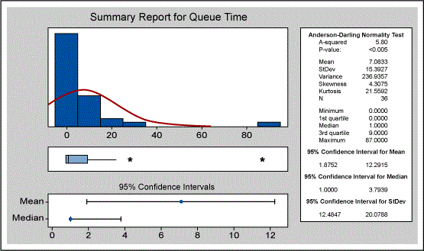

Figure 10: Summary Report for Queue Time – Before

Figure 11 shows the improvement the project was able to make. At approximately 2.5 months into the deployment of changes into production, the mean was shifted down to 2 days with a low standard deviation of 3.

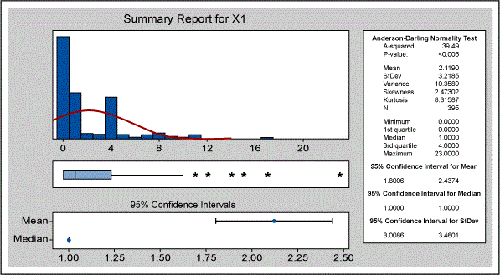

Figure 11: Summary Report for Queue Time – After

**Project Results**

The initial project goals became obsolete due to the significant improvements made during this project. While the charter notes the goal was to increase the number of POs by 6 POs per associate to increase productivity, the changes implemented during the Improve phase added far more productivity than expected. We experienced a shift from 19 full-time employees (FTEs) issuing purchase orders to two FTEs. Between the 2 FTEs and the vastly improved streamline process, the PO per associate ratio increased from 44 POs per associate to 56 POs per associate – far exceeding our initial project charter goals.

Further results included:

* A significant shift from a model in which the focus of global procurement associates was tied to a supplier to one in which the associates focused on categories instead. This resulted in team members having a more complete industry perspective, which led to further cost reductions as associates became better at negotiating market prices.
* Shift from a focus on processing tactical work to a strategic view.
* Associates were easily able to exceed the costs savings quota (SAR) of $5.5M and have continued to do more with fewer FTEs.

**Control**

We developed a control plan that includes two key features:

1. Each manager has a built-in dashboard that shows every employee that reports to them, the number of POs in their queue waiting for approval, the visibility to what is currently in the P2P queue waiting to be sourced, and the overall cycle time for each group (Strategic Sourcing and P2P).
2. Managers have the ability to see [bottlenecks](https://www.isixsigma.com/methodology/theory-of-constraints/applying-theory-constraints-manage-bottlenecks/) in real time and can shift requisitions to other associates to ensure no one person is overwhelmed.

**Hidden Project Impacts**

Once in the Control phase, more benefits appeared that went beyond the project’s original scope captured in the project charter. These bonus benefits included:

* Several areas that were previously manually sourced were able to be shifted to catalogs and, thus, auto-sourced.
* The revised categories aligned with a larger corporate focus of hiring IT lifecycle managers allowing for greater collaboration and focus.
* More specialized knowledge around categories was developed, which helped negotiations and relationships with various other business units.

Types of Process Performance Metrics

Process Performance Metrics, also called **KPI’s (Key Performance Indicators)** focuses on how the task is being performed by measuring performance and if individual goals are being achieved.

This indicator should be measured by a ratio (generally represented by a number) which portrays the progress of the process as a whole or in part.

Strategic Process Performance Metrics serve to show if the organization is achieving the objectives set by senior management, so-called strategic goals. A widely used tool to assist in determining these goals is the [**Balanced Scorecard**](https://en.wikipedia.org/wiki/Balanced_scorecard).

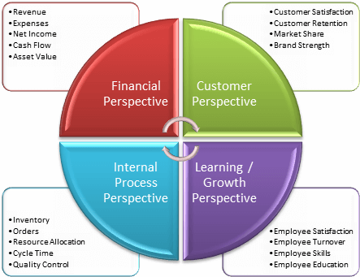

Types of Process Performance Metrics

* Efficiency Indicators
* Effectiveness Indicators
* Capacity Indicators
* Productivity Indicators
* Quality Indicators
* Profitability Indicators
* Competitiveness Indicators
* Value Indicators

We will detail each of them so that you understand them better:

Efficiency Indicators vs. Effectiveness Indicators

Effectiveness is the relationship between the expected results and the obtained results: the best way to do that is = **achieve the expected results.**

Efficiency is the relationship between the results achieved, and the resources used = making things the best way using the least amount of resources.

We can say that efficiency is to be effective using a minimum of resources. Focusing on the process and resources applied to, for example, **reduce costs.** Effectiveness already focuses on the product and the obtained results and can bring benefits, through **higher profits**.

**Capacity Indicators:** The ratio between the amount that can be produced and the time for this to occur. For example, the automaker X is capable of producing 200 cars per month.

**Productivity Indicators:** The ratio between the outputs generated by a job and the resources used to do it. Example: A worker can install 20 m2 of flooring in an hour. Another can install only 17 m2 of flooring in an hour. Therefore, he is less productive than the first. See also[**How do you increase productivity at work? Check out 5 valuable tips.**](https://www.heflo.com/blog/productivity/increase-productivity-at-work/)

**Quality Indicators:** The relationship between total output (total produced) and the outputs suitable and appropriate for use, i.e., without faults or deformities. Example: 980 pieces suitable for every 1,000 produced (98% compliance).

**Profitability Indicators:** The percentage relationship between profit and total sales. Example: a company that sold US$200,000.00 of goods and calculated a US$20,000.00 profit. So profitability is 10%.

[**Return on Investment (ROI)**](https://en.wikipedia.org/wiki/Return_on_investment)**Indicators:** The percentage relationship between the profit and the investment made in the company. Example: the same company from the previous example invested US$500,000.00, with a US$20,000.00 profit. The yield was 4%.

**Competitiveness Indicators:** A company’s relationship with the competition. Market share can be used for this.

**Effectiveness Indicators:** Effectiveness is the combination of efficacy with efficiency.

**Value Indicator:** The relationship between the perceived value when you get something (a product, for example) and the amount spent to obtain it.

Learn more: **Understand in detail how to cut costs in your business,**[**find it here.**](https://www.heflo.com/blog/cost-management/how-to-cut-costs-in-business/)

Why use Process Performance Metrics?

* They provide the information that the manager needs for each stage of the process
* They provide greater **accuracy** in managerial decision making
* They aim to bring more efficiency and effectiveness to processes
* They bring **speed**, a better understanding, and **transparency** to disclosing results
* Process Performance Metrics become the measure of a company’s excellence
* They allow the creation of a **dashboard** with all the information available in a panoramic way

View more: [**Business Process best practices, here.**](https://www.heflo.com/blog/bpm/business-process-management-best-practices/)

General concepts of Process Performance Metrics

**Indices:** the number that depicts the performance earned in a process by the Process Performance Metrics

**Goals:** are the values to be aimed for in a predetermined period, using the Process Performance Metrics

**Tolerance:** If you doesn’t reach the goal, there is a limit of tolerance that will show how serious the result is. Values outside this tolerance range indicate that the conduct of the process is critical and some action should be taken.

The importance of using Process Performance Metrics

Process Performance Metrics are used to monitor the activities of the company. I.e.**track and follow the progress** of the business, collect relevant information and make it available in an accessible way so that managers can study it and make the right decisions. It brings efficiency and efficacy to the processes and thereby creates positive results for the company. Therefore, Process Performance Metrics are critical for the management of a BPM process. Why? They bring to light the necessary information so that you can **analyze the processes** to improve them continuously to achieve strategic business objectives.

**DEVELOP CORRECT SIX SIGMA PROJECT METRICS**

By ****[**Shree Phadnis**](https://www.isixsigma.com/members/Shree-Phadnis/)

[**3 COMMENTS**](https://www.isixsigma.com/methodology/balanced-scorecard/develop-correct-six-sigma-project-metrics/)

**0**

One of the crucial elements of the project charter in the define phase of a Six Sigma project is the selection of project metrics. Project metrics selected should reflect the voice of the customer (customer needs), as well as ensure that the internal metrics selected by the organization are achieved. Metrics selected should be simple and straightforward and meaningful. Metrics selected should create a common language among diverse team members. When drafting metrics for a particular project one should consider how the metrics are connected and related to key business metrics. Typically there is no one metric that fits all the requirements for a particular situation.

**Developing Project Metrics**

The most common approach used by teams is to understand the problem statement, brainstorm metrics, and finally decide what metrics can help them achieve better performance. The team then reviews these metrics with executive management to ensure that they are in synergy with the overall strategy of the business, and an iterative approach may be utilized. Care should be exercised in determining what is measured. Metrics should be based on what, in fact, needs to be measured to improve the process, rather than what fits the current measurement system. Metrics need to be scrutinized from the value they add in understanding a process.

**Balanced Scorecard Approach to Metrics**

Many Six Sigma professionals advocate the use of a balanced scorecard type of approach for the selection of project metrics as a method for ensuring that the project meets both customer and business needs. The balanced scorecard approach includes both financial and non-financial metrics, as well as lagging and leading measures across the four areas or perspectives: financial, customer, internal processes, and employee learning and growth. Lagging measures are those that are measured at the end of an event, while leading measures are measures that help as achieve the objectives and are measured upstream of the event.

**[Handpicked Content:   Bringing the Balanced Scorecard Back to Life](https://www.isixsigma.com/methodology/balanced-scorecard/bringing-balanced-scorecard-back-life/" \t "_self)**

Most balanced scorecard metrics are based on brainstorming, however the approach of brainstorming can have limited success in establishing sound metrics that have a good balance between lagging and leading measures. Typical brainstormed balanced scorecard metrics utilized in Six Sigma projects can be summarized in the below. The primary issue in utilizing a scorecard is that it might not reflect the actual strategies applied by the team for achieving breakthrough in their project.

**Example Project Balanced Scorecard**

|  |  |
| --- | --- |
| Financial   * Inventory levels * Cost per unit * Hidden factory * Activity-based costing * Cost of poor quality * Overall project savings | Customer   * Customer satisfaction * On-time delivery * Final product quality * Safety communications |
| Internal Business Processes   * Defects, inspection data, DPMO, sigma level * Rolled throughput yield * Supplier quality * Cycle time * Volume shipped * Rework hours | **Employee Learning and Growth**   * Six Sigma tool utilization * Quality of training * Meeting effectiveness * Lessons learned * Total trained in Six Sigma * Project schedule versus actual date * Number of projects completed * Total savings to date |

Instead of utilizing the Balanced Scorecard approach described above, the teams can employ a more effective method by answering the questions in the figure given below. This approach helps team members understand the objectives of the project from each of the four perspectives.

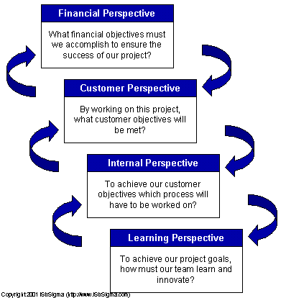

Figure 1: The Four Perspectives

Once the team has brainstormed for each of the four perspectives, the various objectives that must be met by the project will be more clear. These objectives can then me mapped in a strategy map cutting across all the perspectives and projects of the organization. The arrows help in understanding the cause and effect linkages in the strategy. The next illustration shows an example of a strategy map applied.

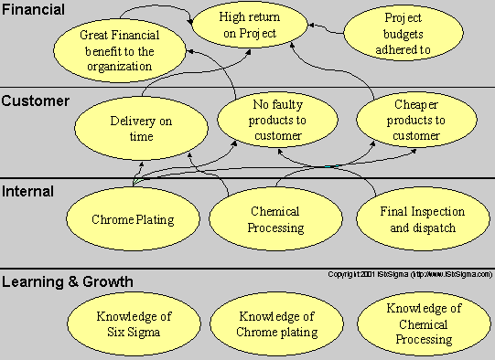

Figure 2: The Strategy Linkages (Example)

**Conclusion**

Once the strategy map for the project is determined, the team can begin brainstorming appropriate metrics for each of the objectives and, while doing so, maintain a balance in selection between leading and lagging measures. This kind of an approach ensures that the team selects a set of metrics that are aligned with the strategy used by them on the Six Sigma Project. Metrics selected in this way not only ensure that appropriate metrics are developed but also help the team in the project planning and creates a purpose of direction for the team.

**MERGING SIX SIGMA AND THE BALANCED SCORECARD**

By ****[**Bradley Schultz**](https://www.isixsigma.com/members/bradley-schultz/)

In an era of complexity and contradiction, many healthcare organizations are seeking bold strategies for leading and managing change. While concepts behind the balanced scorecard and core Six Sigma methodologies are not new, a powerful management tool can be crafted through the unification of these two proven strategies. An approach that combines the targeted performance indicators of a balanced scorecard with the statistical rigor of Six Sigma can be used to effectively focus an organization on the achievement of strategic goals – in essence, creating the ultimate “management cockpit.” Adopting this structured approach to planning, managing and monitoring improvement brings cohesion to conflicting constituencies and builds confidence in proposed process improvements. In turn, this confidence can have a measurable impact on the organization by accelerating the implementation of change, often viewed as a delicate balance between cost, quality and efficiency.

**The Case for Change**

Healthcare today is experiencing both the best and worst of times. Countless lives are saved daily by medical breakthroughs, dedicated practitioners and state-of-the-art technologies. Yet, within this trillion-dollar industry amazing medical feats are juxtaposed against systemic failures and disgruntled stakeholders. Workforce shortages further constrain a system facing a rising demand for services. Advanced technology is often overlaid on archaic processes. As some emergency departments are forced to close, others find themselves overcrowded and understaffed.

Especially frustrating are reimbursement challenges that continue unabated. These challenges are now accompanied by significant changes in the payer mix, moving steadily away from government toward private or industry payers, as illustrated in Figure 1. History indicates that the combination of this shift in payer mix with the rise in healthcare premiums will trigger a market reaction. Figure 2 illustrates this anticipated reaction by comparing the annual percent change in healthcare premiums to the annual percent change in the consumer price index as an indicator of general inflation.

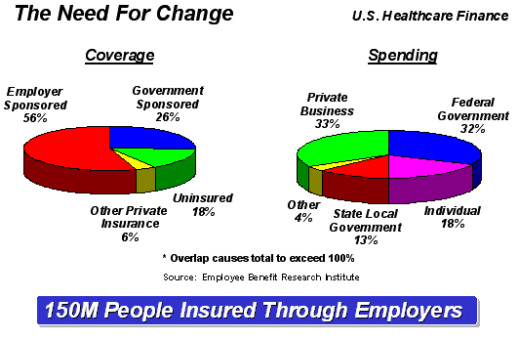

Figure 1: U.S. Healthcare Coverage and Spending

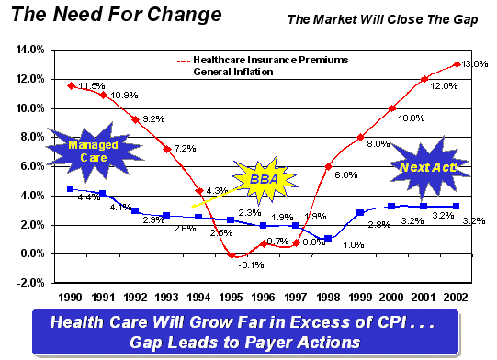

Figure 2: Healthcare Premiums vs. General Inflation

The market began its reaction, in the form of managed care, to the wide gap existing prior to 1990. This gap decreased significantly until the implementation of the Balanced Budget Act (BBA), and by 2002 it had widened again to nearly 10 percentage points with further market reaction anticipated. There are two significant risks associated with the next market reaction: 1) government intervention and 2) industry consequently recasting providers as mere vendors. The industry is at a critical juncture, facing a growing need for systemic change but lacking the infrastructure and digitization that could provide a clear line of sight from strategy to execution and impact. Under mounting pressure to provide better care using fewer resources, some organizations are seeking alternative management models, realizing they can no longer conduct “business as usual.” One solution to help organizations truly align strategic objectives with a clear measurement of impact may be combining the rigor of Six Sigma with the balanced scorecard approach. A balanced scorecard approach provides the mechanisms to drive organizational alignment, sustain improvements and maintain equilibrium across the enterprise. Based on statistics and aspects deemed most ‘critical to quality,’ Six Sigma could further focus the organization’s improvement efforts. Such an approach that identifies and statistically quantifies the impact of causal factors on healthcare’s value chain would provide organizations with a solid foundation for change.

**Healthcare’s Value Chain**

Understanding healthcare, from a business perspective, is critical to ensuring the long-term viability of a delivery system. It is also a prerequisite to applying both the balanced scorecard approach and Six Sigma methodology. Six Sigma originally grew from a setting that was primarily industrial and product-focused. Within this environment, operations are performed on raw materials and as a result they become more valuable component parts. These component parts are then built into higher-level assemblies and ultimately products of progressively increasing value. The value chain for healthcare differs significantly from this model and is illustrated below in Figure 3.

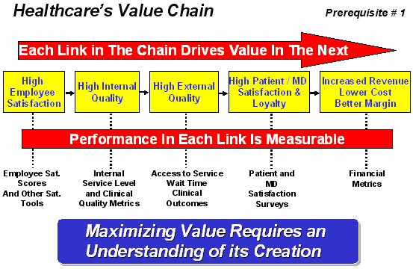

Figure 3: Healthcare’s Value Chain

The value chain for healthcare begins with highly satisfied, dedicated and well- motivated care providers. This produces high internal quality, which relates to process steps that are felt by the institution and are not directly felt by the patient or referring physician. An example of an internal quality metric is the cycle time for the transcription of a radiology report. This represents an interim step in the process that begins with the recognition of need for the exam and ends with the authenticated report in front of the clinical decision maker. Naturally then, high external quality follows from high internal quality. In other words, quality in those steps that are felt by the customer leads to high customer satisfaction and loyalty. This, in turn, leads to revenue and margin, completing the value chain.

**[Handpicked Content:   Six Sigma in Government: Focusing on the Customer](https://www.isixsigma.com/methodology/balanced-scorecard/six-sigma-government-focusing-customer/" \t "_self)**

When appropriate performance metrics are aligned along the value chain, they provide greater insight into how the system is performing today, and what it may anticipate in the future. This concept is illustrated in Figure 4. In this illustration the organization under consideration is operating well in its financial and customer satisfaction metrics as indicated by the upward pointing green arrows. Employee satisfaction and internal quality are poor as indicated by the downward pointing red arrows. As a result, external quality felt by the customer is beginning to decline as indicated by the yellow arrow pointing sideways. It is intuitive that if this trend continues, customer satisfaction and financial performance will begin to decline as well.

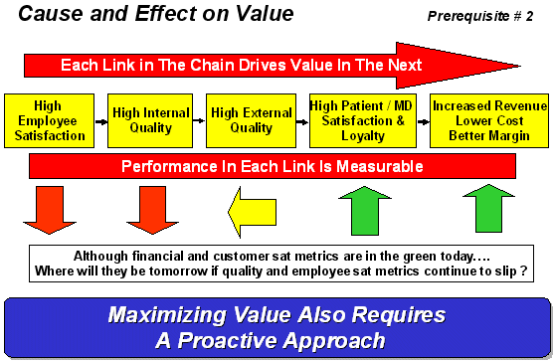

Figure 4: Cause and Effect on Performance of Value Chain

The balanced scorecard approach is based upon understanding healthcare’s value chain and aligning both strategy and the extended delivery teams’ behavior to focus on those activities necessary for the sustained creation of value. Six Sigma methodology is based on statistically quantifying the impact of causal factors on the variability of results. When applied in concert, they represent powerful tools that can be effectively deployed to align the organization’s vision, mission, strategy and specific behaviors toward the sustained creation and delivery of value.

**Creating Organizational Alignment**

Most healthcare delivery systems in the United States publish a vision or mission statement. Most institutions also undergo a rigorous annual planning process. Fewer organizations take one more step by translating the resultant strategic imperatives into families of clear, simple metrics aligned to the value chain. Even fewer have made these metrics appropriately visible and actionable at all levels. Generally written at the 30,000-foot level, vision and mission statements are designed to elicit basic agreement from all team members. When vision and mission are translated into specific behaviors, however, agreement is less immediate and conflict may arise among various stakeholder groups. Translating strategic imperatives into a network of clear, simple metrics is the first step in the balanced scorecard approach. Alignment of these metrics along the value chain is Step 2, and is illustrated in Figure 5.

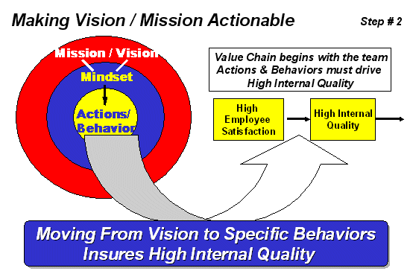

Figure 5: Making Vision and Mission Actionable

The remaining steps in using the balanced scorecard approach to create organizational alignment include the following:

Step 3 – Assessment of the organization’s capabilities  
Step 4 – Cause analysis  
Step 5 – Resource deployment  
Step 6 – Alignment of systems and structures  
Step 7 – Monitoring progress and continually raising the bar

Many of the statistical tools and process improvement techniques associated with Six Sigma lend themselves well to the accomplishment of these subsequent steps and are illustrated in the following sections.

**A Six Sigma Primer**

The philosophy that underlies the Six Sigma process begins with the fundamental assumption that unless we understand a process mathematically, we know little about it. If we know little about it, we are not in a position to control it. If we are not in a position to control it, then we are at the mercy of chance variation.

**[Handpicked Content:   Scorecards Help South African Bank Reap Savings](https://www.isixsigma.com/methodology/balanced-scorecard/scorecards-help-south-african-bank-reap-savings/" \t "_self)**

In the simplest of terms, Six Sigma is a quality improvement methodology that provides a systematic approach to the elimination of defects that affect something important to the customer. Those aspects of service that are of importance to the customer are termed critical to quality, or CTQs, in Six Sigma jargon. The tools associated with Six Sigma are qualitative, statistical and instructional devices for “observing” process variables, “quantifying” their impact on outcomes, as well as “managing” their character. Six Sigma is based upon three simple principles:

1. What is important to the customer? A customer is defined as anyone who receives a product, service or information. Therefore, when coupled with the balanced scorecard approach…internal quality impacts internal customers and external quality impacts external customers.

2. What is an opportunity? An opportunity is represented by every chance to get something right…or get it wrong.

3. What defines success? Every result of an opportunity either meets the customer’s CTQs and is a success, or fails to meet the customer’s CTQs and is a defect. In Six Sigma, an indicator of success or failure is referred to as defects per million opportunities

Every human activity contains variation. The term “Sigma” is a symbol for standard deviation, a measure of variation. Six Sigma refers to the idea of being able to achieve six standard deviations between the mean performance of the process and the customer-determined specification limit. If Six Sigma performance is achieved in a process, then that process will generate less that four defects (occurrences of getting it wrong) per one million opportunities.

The idea of measuring the number of standard deviations that fit between the mean performance of a process and the customer’s expectation (translated into specification limits) is referred to as the process Z-score. The Z-score allows for comparative analysis of the performance of dissimilar processes, based upon the tendencies of each to either satisfy or disappoint their respective customers, the higher the Z-score the less probability of customer disappointment.

**Making Quality the Operating System**

Each metric in the value chain is assessed based upon its ability to satisfy or disappoint its customer. Referring back to Figure 4, this is the method whereby the status of each link in the chain is evaluated. Employing this approach allows the institution to essentially make quality the operating system.

A top level institutional Scorecard must be translated to the department level. At the department level, those factors that have the greatest impact on the top level Scorecard must be identified and rigorously controlled. This is another significant opportunity to employ Six Sigma methodology. A typical Six Sigma project will focus on a specific metric referred to as the project’s “response variable” or Y. The variation in this Y is a function of one or more causal factors, referred to as Xs. The idea is to mathematically understand the contribution of causal factors to variability of the project’s response variable or Y, before specific solutions are designed, thereby maximizing the impact of the solution.

By creating statistical linkages between the Y, metrics on the balanced scorecard and the X(s), causal factors, the Six Sigma methodology augments the balanced scorecard approach in two important ways. First, every link in the value chain is a causal factor to the subsequent link. Referring back to Figure 4, each link may be thought of as a Y in and of itself, and as an X to the next downstream link in the chain. Second, as the value chain metrics at an institutional level are flowed-down to departments, quantification of the causal Xs at a department level will pinpoint specific processes and behaviors that have the greatest impact on the value chain. This provides the foundation for Step 4 (cause analysis).

**[Handpicked Content:   Is Lean the Secret to Curing Healthcare?](https://www.isixsigma.com/industries/healthcare/lean-secret-curing-healthcare/" \t "_self)**

In cause analysis, two strategies are deployed with the same objective – focusing limited resources on those activities that represent the greatest return on investment. First, by retaining performance data month to month along the value chain, a regression model may be built indicating the potential impact of changes in one link of the value chain on performance in successive links. This model also can highlight where there is no verifiable statistical linkage, leading to three critical outcomes:

1. Ensuring the right metrics have been selected.  
2. Ensuring these metrics are measured properly.  
3. Focusing senior level management on one overall deployment strategy

During the analysis phase, the team identifies the factors or Xs likely to have the greatest impact on the response variable. These factors are classified as either controllable or uncontrollable. If a causal factor (X) is controllable and contributes significantly to variability in the response variable (Y), then an opportunity to achieve a better result presents itself by controlling the causal factor. By focusing on causal factors that have a statistically proven impact on a process, the organization gains an important advantage in being able to predict the effect of proposed changes and create an easily understood family of value propositions.

**Aligning Systems and Structures**

So far, we have translated the organization’s strategy to the value chain, assessed the organization’s capabilities and discovered which projects will have the greatest impact. In the analysis phase, we explored the underlying factors that actually drive results. Each phase is integral to the overall process and ensures that the team is using the right techniques to focus on the right objectives for the right reasons.

Taking an improvement initiative to the next level, however, also requires a careful examination of existing systems and structures. In many cases, the way an organization’s systems and structures are aligned fundamentally conflicts with the objectives they are trying to achieve. It’s important to begin by making sure appropriate resources are deployed where they will have the greatest impact. It is also necessary to look at seven additional elements that are key to the success of the initiative, and critical questions that must be answered:

**Organizational design:** Is your quality program contained within a single department or is the concept of quality spread across every part of the business?

**Staffing:** Are you selecting the “best and brightest” from your staff to lead quality and process improvement efforts?

**Development:** Have you provided options for continuing education, experiential or project-based training and cross-functional capabilities?

**Measurement:** Are your projects supported by the right metrics and aligned with your strategic objectives? Are your performance measurements designed to drive organizational success?

**Rewards/recognition:** Is there a consistent process in place for rewards and recognition linked to key metrics?

**Communication:** Does the organization understand the importance of clear and consistent communication?

**Information Technology:** Are there sufficient IT solutions in place for project funnel management, financial linkage and program monitoring?

**Gaining Control**

The last and continuing step in this process involves monitoring changes and key metrics. That is the purpose of the balanced scorecard itself – to serve as a tool that assures the achievement of the organization’s strategy on an ongoing basis. The balanced scorecard should have a top level appearance similar to the illustration in Figures 3 and 4, along with the ability to drill down in each one of the five top level sections and review the metrics associated with those activities that create the greatest organizational leverage.

The challenges confronting healthcare are complex, and no overnight solution will make the problems disappear. Taking a calibrated approach to performance improvement, however, can help hospitals and health systems regain control and realize substantial benefits. Combining Six Sigma with the balanced scorecard may be the best way to reach and sustain a new level of organizational excellence.

1. R-squared measures proportion of variation in your dependent variable (Y) explained by your independent variables (X) for a linear regression model. Adjusted R-squared adjusts the statistic based on the number of independent variables in model [↑](#footnote-ref-1)